Meet the School Counselor

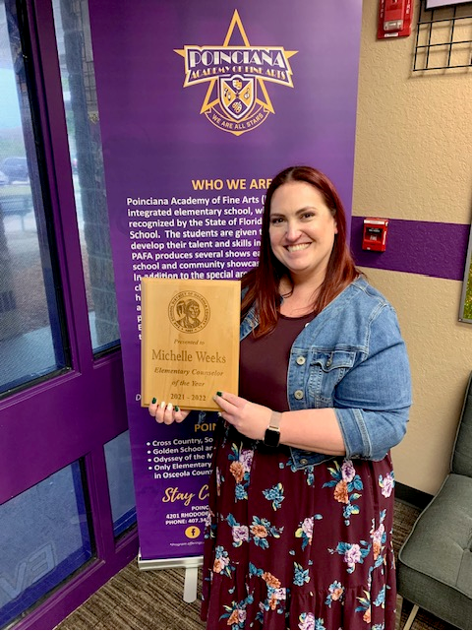

About Me

**Contact Information**

**Email:** [**Michelle.Gilson@osceolaschools.net**](mailto:Michelle.Gilson@osceolaschools.net)

**Phone:**

**407-343-4512**

**What I do**

* **Small groups (helps students build skills)**
* **Classroom Lessons (Bullying, tattling, friendship, kindness)**
* **Consultations with teachers and parents**
* **Help students with coping strategies**
* **Lunch Bunch**
* **Individual counseling (worry, friendship, emotions)**

**Hello PAFA families! My name is Ms. Gilson and this is my 7th year as a school counselor at PAFA. I graduated from University of Central Florida with my Bachelors in Psychology. I pursued my Master’s Degree at Palm Beach Atlantic University in Counseling Psychology. I love being a school counselor and look forward to serving your family this year.**